**Session 22:**

**• Data Driven Decisions**

Data-driven decision-making is an approach that emphasizes using data and analysis. It involves data sources as customer feedback, market trends, and financial data to guide decision-making processes.

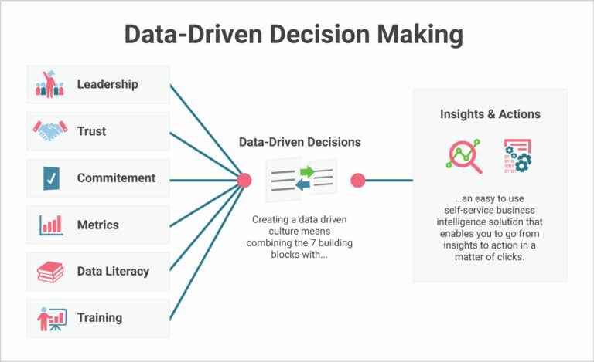

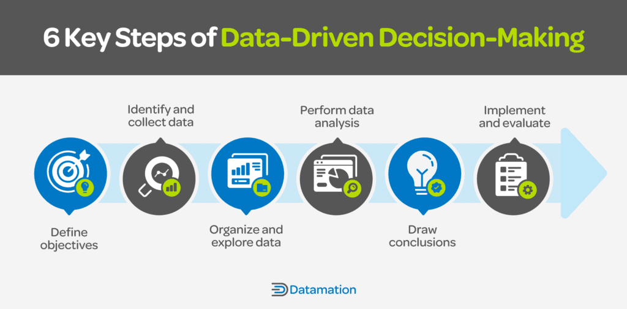

**Data-Driven Decision-Making Examples**

Different types of businesses use data for targeted marketing, inventory management, personalized recommendations, and preventing customer churn:

1. **Amazon:** Uses data to **segment customers** based on location, demographics, and buying behaviours to build targeted marketing campaigns.
2. **Walmart:** Uses **historical data** and predictive analytics to strategically place holiday items across stores, optimizing the entire shopping experience.
3. **Netflix:** **Uses data** for customized suggestions, minimizing customer churn and boosting retention rates.
4. **Data-Driven Decision-Making in Education**

Educational institutions use data for analysis to gauge performance, catch warning signs of failing students, and develop curriculum:

* **Purdue University:** Uses a **predictive analytics tool** called Course Signals to monitor performance and predict students at risk of not successfully completing a course.
* **Demand of University:** Uses **data analytics to** make sure course offerings match student demand.

1. **Data-Driven Decision-Making in Healthcare**

Healthcare organizations use data to refine patient care, prevent diseases, and conduct research:

* **Cleveland Clinic:** **Leverages data** to examine the impact of factors outside of the health system on a patient’s health. It also uses analytics to identify patients that would recover successfully at home following surgery.
* **Centers for Disease Control and Prevention (CDC):** Uses data to build informed decisions and establish systems for emergency operations and response.
* **The Broad Institute:** **Uses big data analytics** to **advance drug discovery**.

**Benefits of Data-Driven Decision-Making**

Businesses can transform their operations and position themselves for long-term success by adopting a data-driven decision-making model, improving the experience for their customers and cutting-costs in the process.

* **Improved Customer Experience**

Data-driven enterprises are more customer-focused and gain a deeper understanding of customer journeys. It helps you tailor your business offerings, improve services, and address customer issues effectively. This leads to personalized experiences, stronger customer relationships, and higher revenue.

* **Better Strategic Planning**

By using data to inform our choices, we can set achievable goals and stay ahead of the competition. By creating a common understanding across departments, supporting communication, and encouraging a shared commitment to achieving organizational goals.

* **Growth Opportunities**

it enables you to identify new business opportunities and areas for improvement. It helps uncover trends and patterns for spotting new market opportunities. It also lets your business swiftly uncover bottlenecks and areas you need to work on.

* **Increased Operational Efficiency and Optimized Costs**

Relying on data can uncover productivity bottlenecks and optimize resource use, resulting in better business efficiency. Furthermore, it facilitates accurate demand forecasting, leading to significant cost savings.

* **More Accurate Forecasting**

Since data-driven decisions allow for more accurate forecasts and predictions about the future, it brings about more efficient operations and cost reductions.

**Common Challenges and Misconceptions about Data-Driven Decision-Making**

Businesses in many industries turn to data-driven decision-making for precision and efficiency.

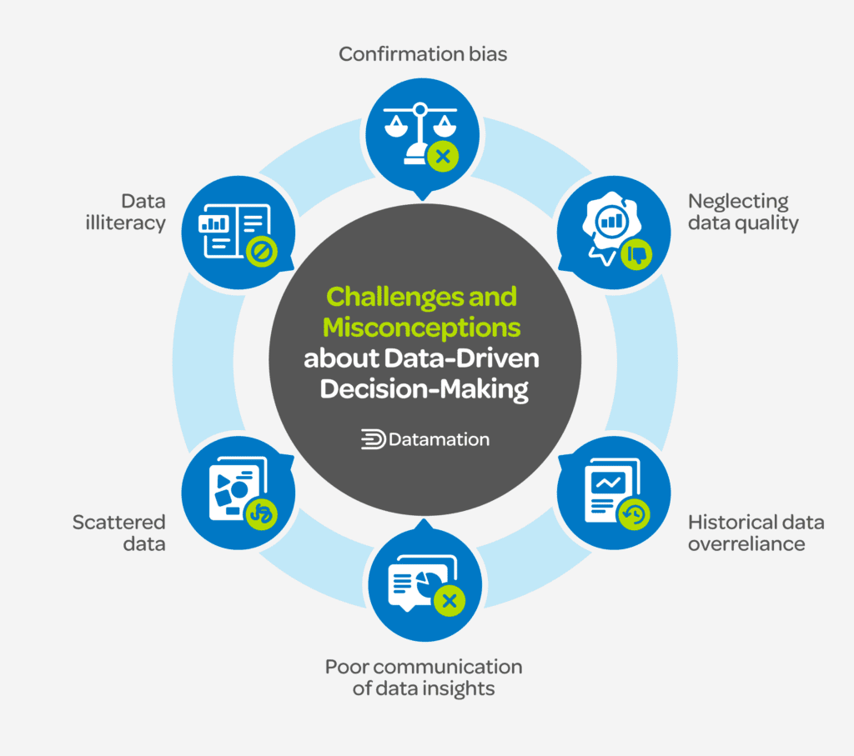

**Neglecting Data Quality**

Poor data quality can lead to inaccurate and unreliable insights, resulting in flawed decision-making. Good [data management practices](https://www.datamation.com/big-data/data-management-best-practices/) involve ensuring the quality of the data

**Scattered Data**

Disorganized data scattered across different departments are like pieces of a puzzle that just won’t fit together. It makes collaboration difficult and decisions end up being all over the place.

**Data Illiteracy**

Data illiteracy can lead to ineffective communication between data professionals and non-technical stakeholders. It can also hinder the successful implementation of a data-driven culture.

**Historical Data Overreliance**

Relying too much on the past can also be a stumbling block. It’s like assuming last year’s fashion trends will always be in style—markets change, trends evolve, and decisions based solely on historical data might miss what’s currently happening.

**Confirmation Bias**

Decision-makers may selectively focus on evidence that confirms their expectations, leading to skewed interpretations and reinforcing existing biases.

**Poor Communication of Data Insights**

Even with accurate data, there can be a breakdown in communication between data analysts and decision-makers, leading to misunderstandings.

**Tools are Used for Data-Driven Decision-Making?**

* Business intelligence (BI) Tools for data visualization and interactive reporting allow you to create dashboards and analyse data trends.
* Big data platforms handle and process massive volumes of structured and unstructured data for enterprises dealing with large datasets and complex data analytics tasks.
* Data governance and quality tools ensure data quality, security, and compliance, so your organization can establish and enforce data management policies.

**• Enterprise Data Management**

Enterprise Data Management (EDM) is a comprehensive approach to defining, integrating, and retrieving data in an organization. This strategic data management practice allows businesses to effectively manage and utilize their data as an enterprise asset by ensuring its accuracy, consistency, and security.

EDM typically includes elements like data governance, quality, integration, privacy, master data management, and lifecycle management.

**Why Is Enterprise Data Management Important?**

Enterprise Data Management (EDM) is essential for several reasons:

* **Improved Decision Making**: High-quality and well-managed data allows for accurate insights and intelligence, leading to more informed decisions.
* **Data Consistency**: EDM ensures that everyone within the organization works with the same information, reducing inconsistencies and enhancing collaboration. This is especially crucial in large organizations with numerous departments working in silos.
* **Regulatory Compliance**: Various industries must comply with strict regulatory requirements related to data and enterprise digital rights management. EDM helps maintain such compliance, avoiding hefty fines and legal repercussions.
* **Enhanced Data Security**: With increasing cybersecurity threats, EDM is vital in securing a company's data assets reducing the risk of breaches and losses.
* **Increased Efficiency and Productivity**: With better data access and management, organizations can streamline their processes, improving efficiency and productivity.
* **Cost Savings**: By avoiding data-related errors and improving operational efficiency, companies can save costs in the long run.
* **Customer Satisfaction**: Accurate and well-managed data contribute to a better understanding of customers' needs, improving experiences and ultimately leading to higher customer satisfaction and loyalty.
* **Competitive Advantage**: Companies that manage their data effectively can extract valuable insights and identify trends and opportunities, leading to a competitive advantage.

**What Are the Pillars of Enterprise Data Management?**

The pillars of EDM define the key areas that need to be addressed to successfully implement EDM, such as the following:

* **Data Governance**: This refers to the overall management of the availability, usability, integrity, and security of data in an organization. It includes establishing policies, procedures, and structures to manage data effectively.
* **Data Quality**: This ensures the completeness, consistency, accuracy, relevance, and timeliness of data. Data quality can lead to accurate analytics, efficient operations, and correct decision-making.
* **Master Data Management (MDM)**: MDM involves establishing a single view of all critical data during the data's lifecycle. It ensures that an organization does not use multiple, inconsistent versions of the same data in different processes.
* **Data Integration**: This involves combining data residing in different formats or sources and providing a unified view of them. It enables the efficient sharing of information across various departments in a company.
* **Data Security**: This involves protecting data from unauthorized access to maintain confidentiality and privacy and to ensure regulatory compliance. Data security includes encryption, access controls, and secure data storage and backup.
* **Data Privacy**: This pertains to the proper handling of data regarding consent, notice, and regulatory obligations. It's about ensuring the data collected is legally, fairly obtained, and protected from misuse.
* **Data Architecture**: This is the design of data and systems, defining how data is collected, stored, transformed, distributed, and consumed.

These pillars are interdependent and must be effectively managed to realize the full benefits of EDM.

**What are the Benefits of Enterprise Data Management?**

* **Improved Decision Making**: EDM provides businesses with accurate and high-quality data, which is integral for making informed decisions.
* **Enhanced Data Quality**: EDM ensures that the data used is clean and reliable, reducing data irregularities and inconsistencies.
* **Increased Efficiency**: By centralizing and streamlining data, businesses can save significant time by making it faster and easier to locate and utilize data.
* **Regulatory Compliance**: EDM ensures that an organization's data complies with relevant laws and regulations, reducing the risk of fines and sanctions.
* **Data Security**: EDM also encompasses data and file security management, minimizing the risk of data breaches and cyber-attacks.
* **Greater Collaboration**: Data centralization makes sharing and use across departments easier, enhancing collaboration and coherence.
* **Reduced Costs**: Businesses can save data storage and management costs by eliminating redundant data and streamlining data management processes.
* **Enhanced Customer Service**: A unified view of customer data improves customer service and personalization.
* **Standardization**: EDM ensures that all data adheres to a standard set of formats, improving interdepartmental communication and understanding.
* **Risk Management**: EDM allows businesses to manage and mitigate data accuracy and reliability risks effectively.

**o Data Preparation and Data Cleaning**

Data preparation is the process of cleaning and transforming raw data prior to processing and analysis.

Benefits of data preparation: Data preparation helps:

* **Fix errors quickly** — Data preparation helps catch errors before processing. After data has been removed from its original source, these errors become more difficult to understand and correct.
* **Produce top-quality data** — Cleaning and reformatting datasets ensures that all data used in analysis will be of high quality.
* **Make better business decisions** — Higher-quality data that can be processed and analyzed more quickly and efficiently leads to more timely, efficient, better-quality business decisions.

**Data preparation steps**

**1. Gather data:** The data preparation process begins with finding the right data.

2. **Discover and assess data**: After collecting the data, it is important to discover each dataset.

3. **Cleaning the data and validate data:** cleaning up the data is traditionally the most time-consuming part of the data preparation process, but it’s crucial for removing faulty data and filling in gaps. Important tasks here include:

* Removing extraneous data and outliers
* Filling in missing values
* Conforming data to a standardized pattern
* Masking private or sensitive data entries

**4. Transform and enrich data: Data** transformation is the process of updating the format or value entries in order to reach a well-defined outcome, or to make the data more easily understood by a wider audience.

**5. Store data:** Once prepared, the data can be stored or channelled into a third-party application such as a business intelligence tool.